|  |  |
| --- | --- |
| **C:\Users\sram\OneDrive - Unitec NZ\ShiuRam\Unitec\Unitec Logos\UnitecHorizontalLogo.jpg** | **ISCG7420**  **Web Application Development**  **Assignment 1**  **Semester 2, 2022** |
| School of Computing, Electrical and Applied Technology | **Due Date: Oct 21st 2022 17:00PM** |
|  | **Total Marks: 100**  **Course Weighting: 60%** |

**Learning outcomes covered in this assignment**

1. Discuss the tools used in providing web-based applications.
2. Design and implement a dynamic web application using a range of languages/technologies/tools.
3. Discuss and evaluate the available data access technologies.

# Assignment information:

* This is an individual assignment.
* Read the given scenario and complete the two tasks.
* For Task 1 you will evaluate two programming languages and two data access technologies and present your findings within a count of 1000 words [+/- 10%], excluding reference list.
* For task 2 you will design and implement a Django web application. Firstly, you will identify the Django models, then create views and templates.

# Assignment Submission:

* Upload your response for task 1 in word format to Moodle “assignment 1-task 1 submission link”.
* For task 2 use the Assignment 1directory of your class GitHub repository to store your task and add your lecturer as a collaborator. Periodically throughout the course your lecturer will clone your repository to check your progress. On the assignment due date (and for up to 72 hours afterwards) your lecturer will download the most recent version of your task 2. You are required to ensure that GitHub always has the latest version of your code.
* For task 2 if you forget to push your most recent changes by the due date, then your lecturer will use the latest version available on GitHub when the deadline is reached for marking. **Make sure you regularly update files. If you use and submit code that you didn’t write, you will fail this assignment, and fail the course. Ask your lecturer for help long before the due date instead of plagiarising.**

**Scenario**

Maungawhau college is upgrading their attendance system. This system allows lecturers to enter student attendance. Students can also view their attendance on the system.

Business Rules:

1. One semester runs one to many courses
2. One course is run in zero to many semesters
3. One course can be separated into one to many classes
4. One class can only run for one course
5. One class can be taught by only one lecturer
6. One lecturer teaches zero to many classes
7. One class holds one to many students’ enrollments
8. One enrollment fit in one class
9. One student enrolls to one to many courses.
10. One student enrollment belongs to one student.
11. One college day runs zero to many classes
12. One class runs on zero to many college days

**Client requirements:**

1. Administrator can login into in the attendance system.
2. Administrator can create/update/delete/show semesters
3. Administrator can create/update/delete/show courses
4. Administrator can create/update/delete/show classes
5. Administrator can create/update/delete/show lecturers
6. Administrator can assign/remove/change/show a lecturer to a class
7. Administrator can create/update/delete/show student
8. Administrator can enrol/remove/show student to classes
9. Administrator can upload students from excel files to the attendance system
10. Administrator/Lecturer can email students when they have poor attendance
11. Lecturer can login into the attendance system
12. Lectures can enter students’ attendances into the attendance system
13. Students can login into the attendance system
14. Students can view their attendance in the attendance system.

Note: there is no need to change password and there is no need for registration.

**Task 1: Technology Evaluation [16 Marks]**

Before you start web development (i.e., in this case attendance system) you will research and evaluate programming languages and data access technologies that can used for the development. Answer the following questions.

**Questions**

1. Evaluate two web programming languages that can be used for this development.
2. Evaluate two data access technologies can be used for this development.
3. Based on your evaluation of questions 1 and 2 recommend a web programme language and data access technology that can be used for development.

**Task 2: Web Development [84 Marks]**

To develop the attendance system, you need to design and implement a dynamic web application using Django, PostgreSQL and/or other available web development tools. You will also host your web application on Heroku with available add-ons. You will upload your code to GitHub. The requirements for the application are given below:

**Part A – Models [29 marks]**

**Follow the given class diagram to create models**

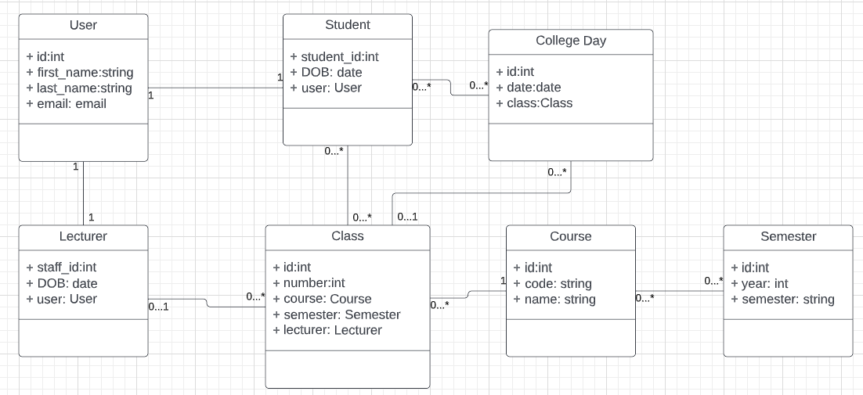

**Part B: Views [35 marks]**

1. View for administrator to login into in the attendance system.
2. View for administrator to create/update/delete/show semesters
3. View for administrator to create/update/delete/show courses
4. View for administrator to create/update/delete/show classes
5. View for administrator to create/update/delete/show lecturers
6. View for administrator to assign/remove/change/show a lecturer to a class
7. View for administrator to create/update/delete/show student
8. View for administrator to enrol/remove/show student to classes
9. View for administrator to upload students from excel files to the attendance system
10. View for administrator/Lecturer to email students when they have poor attendance
11. View for lecturer to login into the attendance system
12. View for lectures to enter students’ attendances into the attendance system
13. View for students to login into the attendance system
14. View for students to view their attendance in the attendance system.

**Part C: Templates: [16 marks]**

1. Template(s) for all administrator’s functions.
2. Template(s) for lecturer’s functions.
3. Template(s) for student’s functions.
4. Authentications on all templates
5. Templates can be reused.

**Part D: Deployment [4 marks]**

**Requirements:**

1. Setup Github for Django
2. Setup Heroku/AWS/other host apps that corresponds to GitHub repositories.
3. Deploy your website to Heroku/AWS/Heroku/AWS/other host.
   1. Procfile
   2. Requirement.txt
4. Firebase storage configured.

**ISCG7420**

**Web Application Development**

**Assessment 1 Mark Sheet**

**Student Names:**

|  |  |  |  |
| --- | --- | --- | --- |
|  | | | |
| Task | Maximum  marks | Your mark | Comment |
| 1. Technology Evaluation | 16 |  |  |
| 1. Web Development |  |  |  |
| 1. Models | 29 |  |  |
| 1. Views | 35 |  |  |
| 1. Templates | 16 |  |  |
| 1. Deployment | 4 |  |  |
| **Total** | **100** |  |  |

**Late Submission of Assignments:**

Assignments submitted after the due date and time without having received an extension through Affected Performance Consideration (APC) will be penalised according to the following:

* 10% of marks deducted if submitted within 24hrs of the deadline,
* 20% of marks deducted if submitted after 24hrs and up to 48hrs of the deadline,
* 30% of marks deducted if submitted after 48hrs and up to 72hrs of the deadline,
* No grade will be given for an assignment that is submitted more than 72hrs after the deadline.

**Assistance to other Students:**

Students themselves can be an excellent resource to assist the learning of fellow students, but there are issues that arise in assessments that relate to the type and amount of assistance given by students to other students. It is important to recognise what types of assistance are beneficial to another’s learning and also what types of assistance are unacceptable in an assessment.

**Beneficial Assistance:**

* Study Groups
* Discussion
* Sharing Reading Material
* Reading the available online and library resources

**Unacceptable Assistance:**

* Working together on one copy of the assessment and submitting it as own work
* Giving another student your work
* Copying someone else’s work, this includes work done by someone not on the course
* Changing or correcting another student’s work
* Copying from books, the Internet etc. and submitting it as own work; anything taken directly from another source must be acknowledged correctly; show the source alongside the quotation
* Don’t copy code from a website or video tutorial and pretend you made it or slightly change it. This will be an instant fail (0%).